Day-2

1.Create a web page which displays your personal details in the below format:

●      Name: xxxx

●      Gender: xxxx

●      e-mail ID: xxxx

●      Mob.No.: xxxx

●      Xth Percentage: xx

●      Inter Percentage: xx

●      Aggregate Percentage in B.Tech: xx

The main heading of the page should be "My Profile" below which the above mentioned details should be displayed.  
Also the left-hand side details like Name, Gender, etc., should be displayed in bold.

2. In this task, we want you to mark up the provided HTML using semantic heading and paragraph elements.

3. In this task, we want you to turn the first un-marked up list into an unordered list, and the second one into an ordered list.

4. Create a hyperlink with in a document.

Sample link: example.com.

5. Create a HTML program for Ordered and Unordered [List](http://learning.microcollege.in/mod/assign/view.php?id=19552)

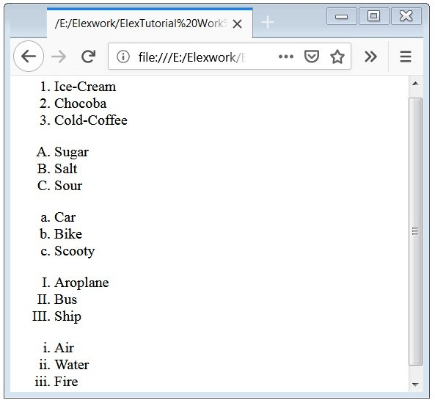

6. Create a HTML program by using text formatting tags,

7. use superscript and subscript tags.

8. create a tourism web page with images, anchor tags, headings and paragraphs.

9. place a  header, image and footer

10.Figure and figcaption

Use image attributes such as height and width and bring a small image as an output.

11. [use del,ins tags](http://192.168.253.177/moodle/mod/assign/view.php?id=17334)